Photography 101: Using a Digital Camera & Making Sharp Photos
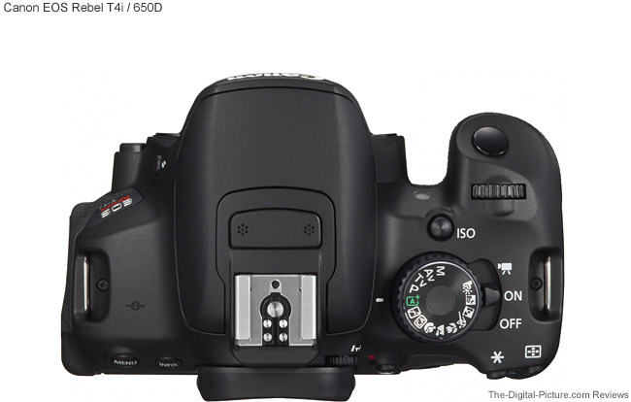

Shutter Button
Flash Button

Shooting Mode Dial
On/Off/Video Switch

Viewfinder

Manual
Aperture Priority
Shutter Priority
Program
FULL AUTO
No Shutter
“Creative Auto”
Portrait
Landscape
Close Up
Action
Night
Daylight

Making A Sharp(er) Image
You never want to miss the perfect “Kodak moment” by fiddling with your camera settings or taking blurry pictures. Make these best practices a habit to ensure your images are focused and well-lit.
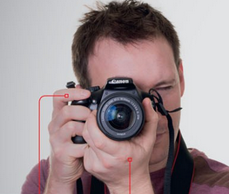
- Stabilize the camera
  - Digital cameras are often heavy and cumbersome, but finding a comfortable and steady way to position them is key to getting a sharp focus. When moving, use the camera strap around your neck, wrist or shoulder to prevent damaging drops. For hand-held shooting, use your right hand to grip the right side of the camera; place your forefinger on the shutter button, thumb on the back of the camera, and three remaining fingers along the side and front. Then, use your left hand to support the camera’s weight and guide the lens by placing it underneath and around the lens. Add extra stability by tucking your elbows into your sides, propping the camera up on a solid object, leaning against something or kneeling down, or setting the camera on a tripod. View this guide for more info.
- Use the viewfinder
  - While many modern cameras have screens on the back of the camera that allow you to see what’s in front of the lens, the only true way to see what will be captured is to look through the viewfinder. Lean the top of the viewfinder against your eyebrow/forehead for extra stability and pay attention to the edges of the frame to guide your composition.
- Test your exposure
  - Even if you’re using an automatic setting, take a few practice shots when you arrive to make sure the photographs won’t be too dark or blurry. This should allow you enough time to change settings or find the best lighting before an event starts.
- ALWAYS pre-focus
  - When relying on your camera’s auto-focus feature (usually a small switch on the camera lens), always pre-focus by gently pressing the shutter button halfway. If you’re looking through the viewfinder, you will see the scene snap into focus and often cameras will make a subtle beep. If you’re happy with the composition after pre-focusing, you can continue pressing the shutter completely down to take a photo. If you’d like to move your subject out of the center of the shot, pre-focus and keep your finger pressing the shutter to ‘lock’ the focus, but then move the camera slowly to recompose the picture before fully pressing down the shutter.
- Get close to your subject(s)
  - Eliminate things that might distract from your main subject (like crowds or cluttered backgrounds) by moving closer and/or zooming in to allow your subject(s) to fill more of the frame. This could mean crouching down to get to someone’s eye level or only focusing on a few people in the room.
- Follow the light (or bring your own)
  - Light affects every aspect of the image, so it is crucial to start paying attention to it. Move yourself or your subject around to find the best lighting for an image. If there is not enough light available, consider using your on-camera flash or moving a light source closer to the subject.
Selecting a Shooting Mode
Cameras are covered with buttons, icons, and phrases that can seem daunting for novice photographers. Familiarize yourself with some common camera modes and practice using them so you can select the right mode for every shot with ease!
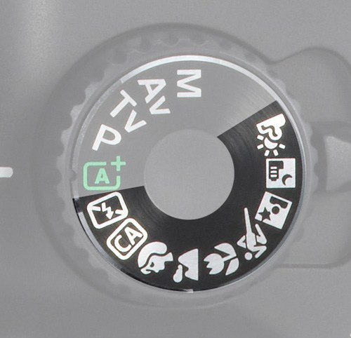
Automatic Modes (for the beginning photographer)
- Full Automatic: Usually denoted by “Auto” or empty rectangle; camera fully controls the exposure settings
        - Use when on-the-go or just starting out
- Automatic, No Flash: Usually a rectangle with a crossed-out lightning bolt; camera controls the exposure settings, but will never use flash
        - Use when wanting full auto, but flash would be inappropriate for setting
      - Creative Auto: Cannon-specific setting (CA); camera controls the exposure, but allows user to adjust certain settings
        - Primarily for intermediate photographers; use when wanting to adjust some automatic settings
      - Portrait: Usually an icon of a person’s profile; camera controls exposure, with an emphasis on shallow depth of field (fuzzy background)
        - Use when taking portraits
      - Landscape: Usually an icon of a mountain; camera controls exposure, with an emphasis on wide depth of field (clear foreground to background)
        - Use when taking pictures of something far away
      - Close Up (Macro): Usually an icon of a flower; camera controls exposure, with an emphasis on shallow depth of field (fuzzy background)
        - Use when taking pictures of something small and/or very close to the camera lens
      - Action: Usually an icon of a person in motion; camera controls exposure, with an emphasis on faster shutter speed (frozen motion)
        - Use when taking pictures of something moving quickly and wanting to freeze their movement in the image
      - Night: Usually an icon of a nightscape; camera controls exposure, with an emphasis on low lighting; some cameras have automatic settings for night portraits and night landscapes
        - Use when taking pictures at night or in very low lighting
      - Daylight: Usually an icon of a cloud and/or sun; camera controls exposure, with an emphasis on brighter lighting
        - Use when taking pictures outside or in similar bright overhead lighting situations

Semi-Automatic Modes (for the intermediate photographer)
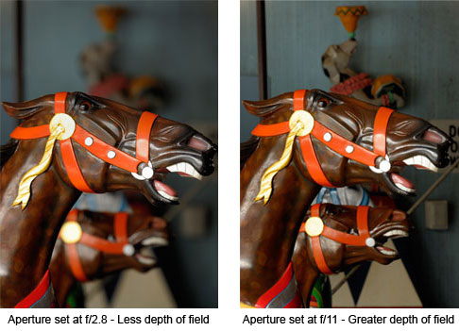
- Aperture Priority: Usually “A” or “Av” (aperture value); Photographer selects the aperture and camera chooses the shutter speed to balance the exposure

  - Use when wanting to control how much of the image is in focus
  - Setting an aperture of 1.4-4 will result in a shallow depth of field where the subject is in focus, but the foreground and background are fuzzy (best for portraits/close-ups)
  - Setting an aperture of 8-22 will result in a wide depth of field where the foreground, subject, and background are all in focus (best for landscapes and distant subjects)
  - More information

Shutter Priority: Usually “T” or “Tv” (time value); Photographer selects the shutter speed and camera chooses the aperture to balance the exposure
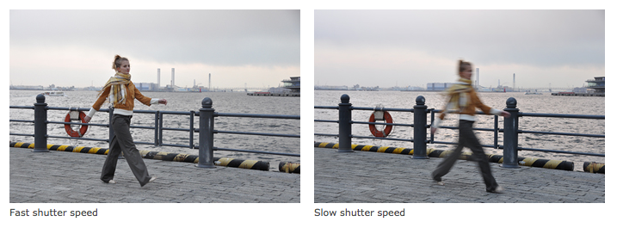

  - Use when wanting to control how much motion is displayed in the image
  - Setting a shutter speed of 1/250-1/2000 or using the on-camera flash will result in frozen motion (best for action images where the subject and/or background figures are moving)
  - Setting a shutter speed of 1 second-1/125 will result in blurred motion (best for images that want to show motion; flowing water, moving crowds, etc.)
  - More information

